Norbury Park LTC Summer Camps 2022

Dear Parent, July 2022

Please find below details of our summer tennis camps. Each 3-hour session (10am to 1pm ) will consist of a coaching, drills, game play and fun based games. Camps are for children aged between 5 and 14. After 1.5 hours the children will have a 20 min break where children can eat snacks if they wish (snacks are not available to buy and should be brought from home).

Each daily 3-hour session will cost £27. Simply tick the sessions you want your child to attend and send the information back to by e-mail headcoach@norburyparkltc.co.uk. Payment to be made by cash or transfer. You will only be contacted if the session you have selected does not run (this will be due to low demand for that day), otherwise please turn up ready for play on your day, don’t worry if you don’t have a racquet, one will be provided if necessary. The sessions will still take place if it rains, as we will organise mini tennis in the clubhouse and other tennis related activities.
 | Week 1 w/c 25.7.22 10am – 1pm | Week 2 w/c 01.8.22 10am – 1pm | Week 3 w/c 08.8.22 10am – 1pm | Week 4 w/c 15.8.22 10am – 1pm | Week 5 w/c 22.8.22 10am – 1pm
Tuesday
Wednesday
Thursday
Friday

1st Child’s Name:…………………………………………………………. DOB:……………….…………………………….

2nd Child’s Name:………………………………………….…… DOB:…………….………………………………

Parents contact number:…………………………… E-mail:…………………………………….…….

How did you hear about the summer camps:……………………………………………………………

Does your child have any disabilities/medical conditions Y/N …………… If YES please specify

Online Banking: Lloyds Bank, Norbury Park LTC, Sort Code: 30-00-08, Account number: 00858236
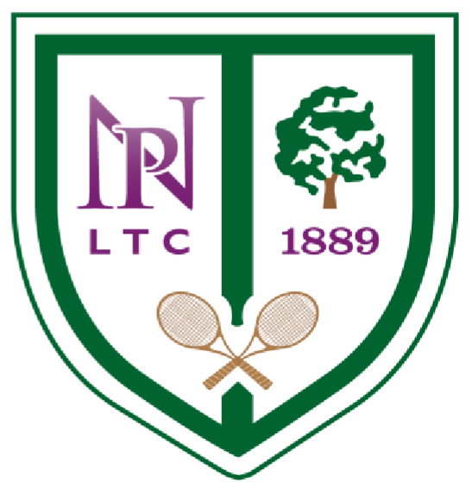

David Lovejoy

Norbury Park Lawn Tennis Club

55
Ederline Avenue

Norbury

London SW16 4RZ

Tel:
020 8765 9454

www.norburyparkltc.co.u
k

