**WEEKLY MATHS CHALLENGE**

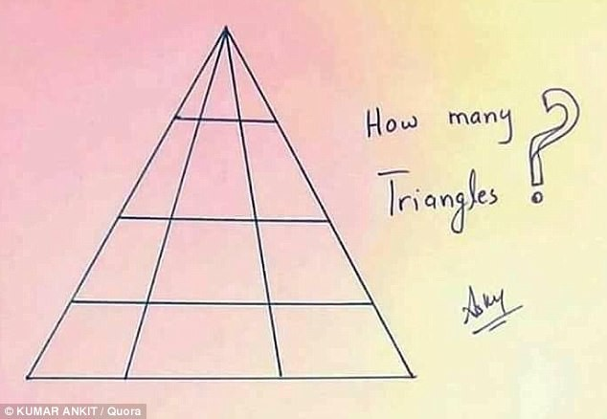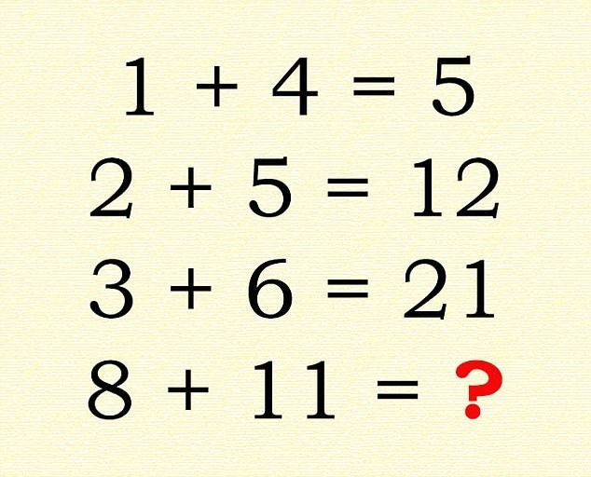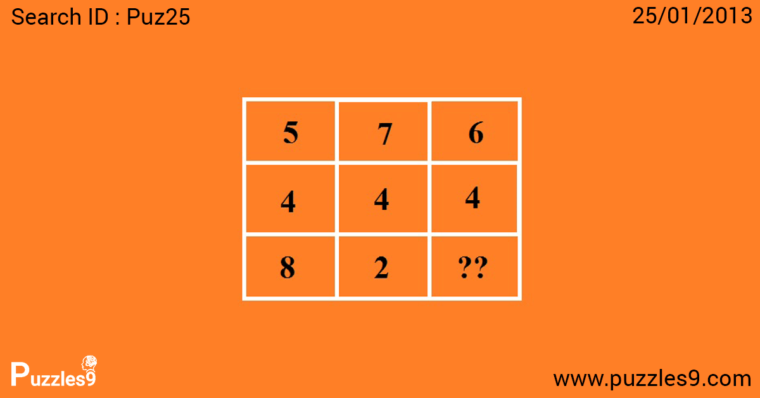

What is the missing answer?

Can you explain how you know?

What is the missing answer? Can you explain how you know?